Tablet Weaving

Una Duckfoot Pam Arnold

651-262-8079

rparnold@bitstream.net

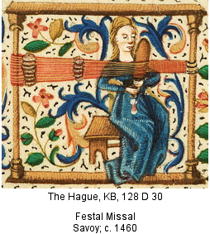
Description:
Tablet weaving is weaving (usually a narrow band) using tablets or cards with holes at the corners to form the weaving sheds. Tablet weaving exposes the warp (up and down threads) rather than the weft (back and forth threads exposed when using the tapestry weave) or both (as plain weave).
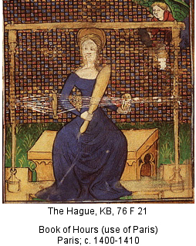
History:
Tablet weaving dates from at least the 8th century BCE. The tablets were made of anything that could be made flattish and relatively sturdy: wood, bone, horn, leather, etc.
Tablets can be of various regular polygons, but squares are currently the most common, and it is what I used. The Oseberg find (~834AD) tablets are also square. Turning the cards changes which threads are on which side (up or down) of the weaving shed, and individual cards may be turned to create various patterns.
Tablet weaving in the middle ages ranged from Egypt to Scandinavia; popularity in any given region has varied with time and fashion.
Tablet weaving produces narrow bands that can be used for sturdy straps or belts or colorful trim. It is also used to create starting or selvedge bands for larger textiles. The Scandinavians, at least, often used them for decorative trim. 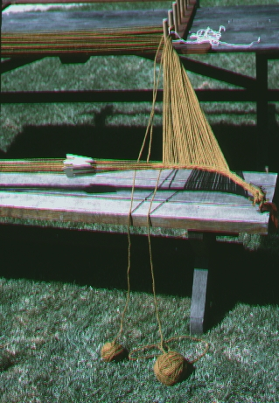
Above is a picture of using card weaving to create a starting edge for loom weaving.
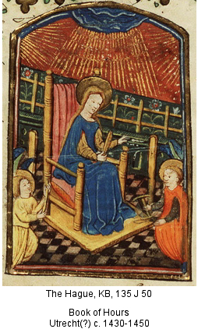
My Goals:
I had done a tiny bit of tablet weaving in college (20+ years ago). I had seen that tablet weaving can be used to make double-sided reversible patterns, and wanted to try it out. I had dreams of a belt with woven-in duck feet.
Method:
To make my tablets, I have used plastic divider sheets that they would have just thrown out at work (free! And ecologically responsible!).
Modernly the tablets are often marked with different colors on the edges for ease of telling which orientation a particular card has. This seemed a sensible thing for a beginner, so I marked the cards prior to warping. I did discover that you need to mark them differently depending on whether they are S or Z cards. There is no evidence they did so in SCA period, and it makes sense because firstly, they would have had a lot more practice than I, and secondly, unless you have LOTS of cards you don’t want to mark them because the S card this time might be the Z card next time.
Often card weaving is done on a back strap loom (with the other end attached to something sturdy), but I used my (modernly produced Xmas present) inkle loom because it is much easier to control the tension. When I did it college the tension (and therefore the width) was all over the place.
For warping, I was assisted by John Devilbiss and Hedy, and advised by Ainesleah. Ainesleah suggested I tie off the warp strings with a modified surgeon’s knot (which did help it not slip before the knot was done), Hedy unwound my string, and John was incredibly helpful by holding the strings while the knots were tied (a firm finger placed just there at the right time is incredibly useful).
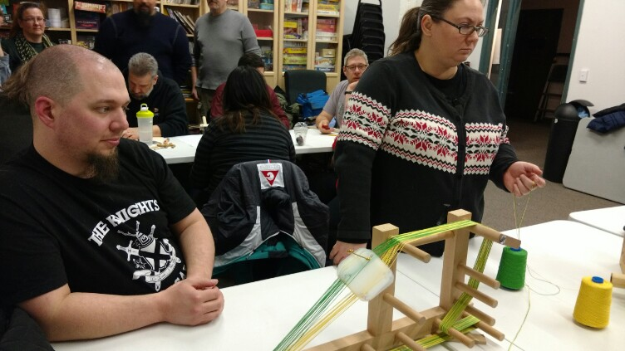
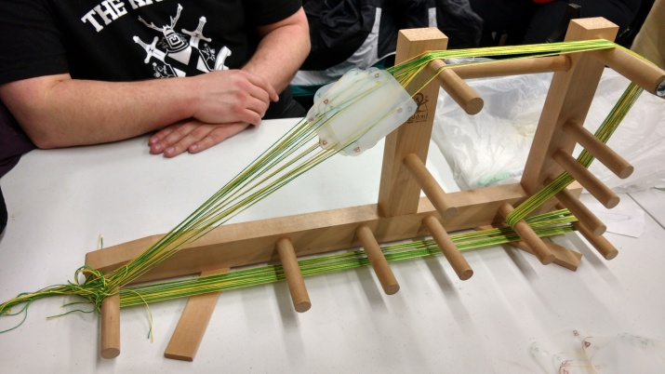
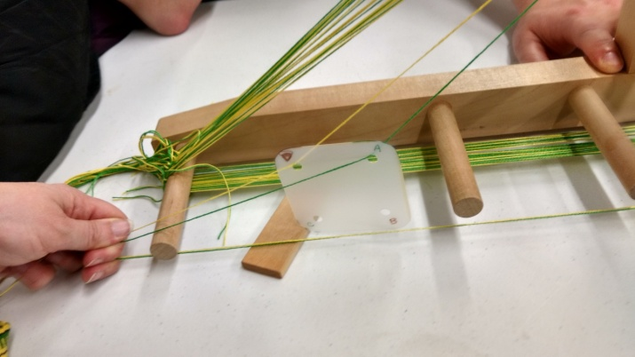
Ainesleah also showed me a way to tie up the cards so they stay put in relation to each other and the warp.

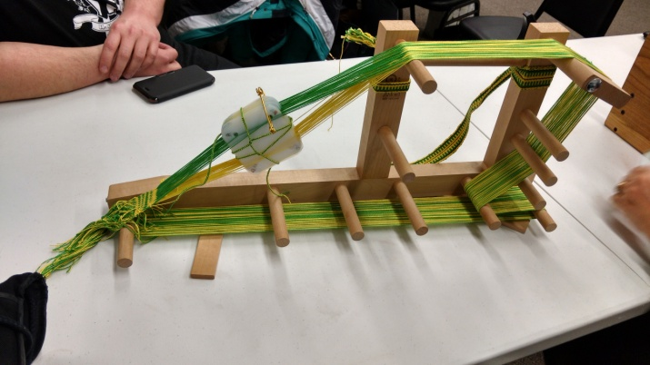
It took me several tries to figure out how double sided weaving works (cards warped 2 adjacent each color, 2 forward & 2 back; rotate 180° to change color)
What I learned:
Several of my tablets turned out to be floppier than they ought to have been; it was sometimes a problem when trying to turn them.
While using the inkle loom frame really helped with the tension, I had to adjust the warp several times because the twists of tablet weaving takes up more of the initial length than regular weaving.
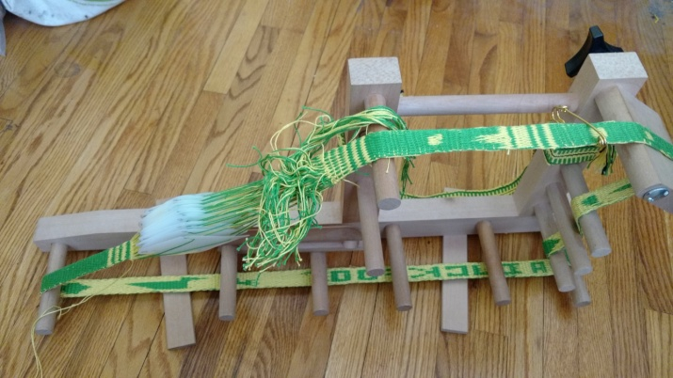
You can see from the pictures that I had initially looped the band around the peg directly above the ‘U’ in ‘Duckfoot’. I am not sure how this would have been handled in a frame like the medieval illustrations pictured.
I also found that when I was pulling the weft thread enough to hide it, the band became much more narrow than I had originally estimated.
While I finally got the hang of double-sided weaving, I found that the resolution is insufficient to make duck feet on such a narrow example. Perhaps on a really wide band. I was able to manage (legible if not particularly artistic) letters, a fish, and a long-beaked waterfowl (loon?)
I did find it interesting that at least half of the people pictured doing tablet weaving in a Google images search were re-enactors.
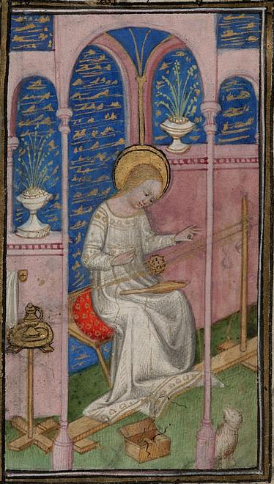

15th (1400-1450) France Cambridge, Harvard University, Houghton Library, MS Richardson 042, fol. 20
References:
Wikipedia Article on Tablet Weaving (it’s at least a good starting point)
http://www.stringpage.com/tw/tw.html , the tablet weaving page from ‘Phiala’s String Page’; Sarah Goslee claims to have been teaching fiber arts since 1992, and appears to be associated with the SCA in PA; at one point her blog references the Pennsic Fiber Arts Pavillion.
http://guenean.com/handoutTW.php , from Jennifer McCaffey’s Homepage, a good how-to page for a beginner.
http://www.cs.vassar.edu/~capriest/textileres.html , Textile Resources for the Re-enactor.
http://www.santacruzhandweavers.org/anneblinks/TW.html , which shows how tablet weaving is used to create selvedge edges for warp- weighted looms; the picture of this is from this website.
http://www.forest.gen.nz/Medieval/articles/Oseberg/textiles/TEXTILE.HTM Oseberg Textiles

