Stab Bookbinding

Una Duckfoot Pam Arnold

651-262-8079

rparnold@bitstream.net

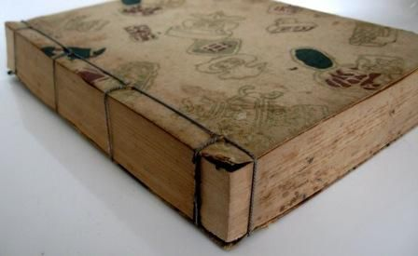Description:
Stab bookbinding is characterized by sewn bindings with the holes poked on the face (near the edge) of the book, rather than the holes being in the fold of the pages. It also is not unusual for the pages to be folded on the fore-edge rather than the sewn edge.
History:
Stab bookbinding was used during the Tang period in China (618-907), became widespread during the Ming Dynasty (1368-1644), and came to Japan during the Muromachi period (1392-1573). It also spread to Korea (introduced in the Goryeo period [918-1392] & widespread by Joseon period [1392-1910]) and Vietnam.
Stab bookbinding became dominant in Japan after the 14th century to the extent that it is often thought of as the only Japanese book form. (Probably because it was dominant [90% of Japanese books] during the Edo period [1603-1867], when Europeans started muscling into the area.) The books are also called pouch books because the pages make pouches; 4-hole books are ‘Chinese style’ and 5-hole books are ‘Korean style’. Pouch books’ name in Japanese, yotsume toji, translates as ‘4-hole’.
It has been suggested that these books have pages of double thickness because the inks and papers used either bled through or had the opposite side of the page damaged by the woodblock printing process. This seems like a good solution to either of these problems.
Covers in traditional Chinese bookbinding tended to be thicker paper, usually dark blue, with yellow silk for Imperially commissioned works. Hard covers were rare and only used for very important books. A white strip of paper with the title was often glued on the edge of the book.
Korean covers were made of several pieces of paper glued together with wheat starch paste, the outer one dyed yellow with cork oak bark, acorns, or gardenia tree fruits. Then the covers were dampened, a thin coating of beeswax added, and rubbed with a smooth stone after being placed over a carved woodblock surface. This produced a more durable and waterproof cover (in addition to the decorative embossing). Korean covers were cut slightly larger than the text block and the 4 edges were folded in.
The Chinese used white silk for the binding while the Koreans used hemp, cotton, or silk, dyed and coated with beeswax. Certainly if you don’t want dye to bleed onto the paper, coat it with beeswax or don’t used dyed thread.
As in Europe, the majority of early books were religious writings.
On the web one may find many decorative versions of stab binding in various patterns; I will focus on the simplest (and therefore likely oldest) pattern. I have been unable to find much information about when the fancier versions appeared; they may be comparatively modern.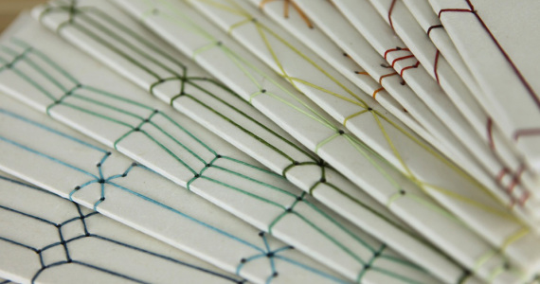
My Goals:
I think this form of bookbinding is an excellent way of gathering groups of single pages (even very thick ones), like class handouts. Can’t find a stapler at the event? What are the odds that you can’t find something to poke holes and a bit of string/thread? It is also a method of bookbinding that uses minimal equipment and thus is a good candidate for a class (no sticky glue to clean up!).
Method:
I am using cotton thread and copier paper rather than silk thread and more traditional paper for economy’s sake. And the cover paper, while blue, is not as heavy as I would like.
Step 1: fold the pages and cut the covers. I have pre-cut pages that I am folding.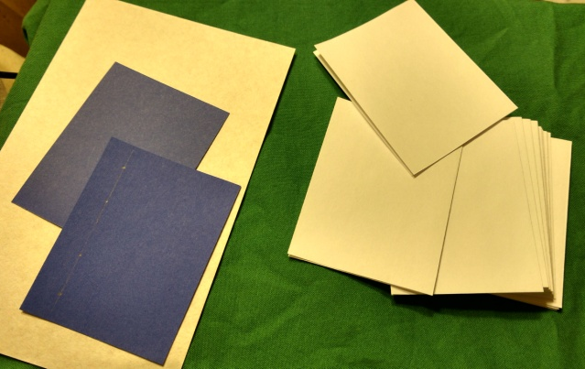
Step 2: measure where to poke the holes. The holes should be inset enough to not tear the paper, and evenly spaced.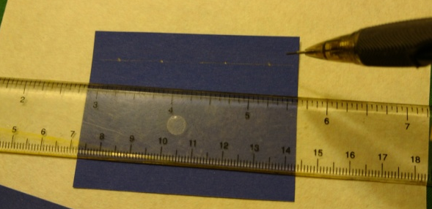
Step 3: poke holes. I use an awl. On some websites it has been suggested to use a power drill if the book is very thick. I suspect that in period they would have made a template for consistency. I have found that I am not exacting enough to exactly line up the holes if I don’t poke through the whole stack at once.
Step 4: sew the book. For 4-hole binding the thread should be at least 3 times the height of the book, more if the book is tiny. I found that for tiny books at least, a pliers was helpful to pull the needle through. Or maybe not having fries for lunch. Or both.
Take the needle and go from the inside out one of the middle holes.
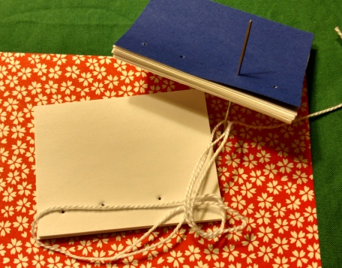
Leave a tail of a few inches to tie into a knot later. Then go around the spine and back up through the same hole you just came out of.
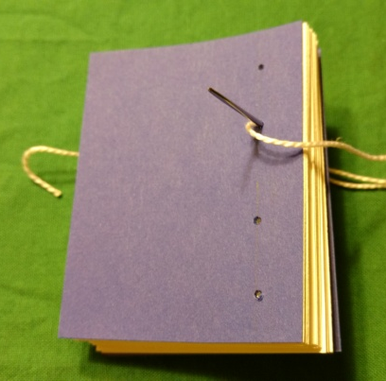
Then go into the next middle hole.
Now loop around the spine and back through the same hole.
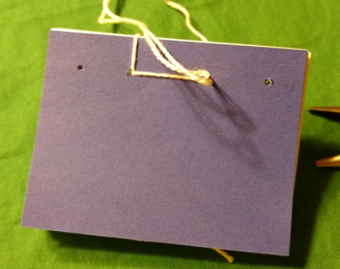
Flip the book over and go into the next hole (the one on the end).
Loop around the spine and go into the same hole.
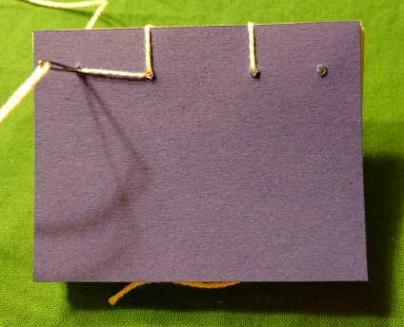
Loop around again, going through the same hole, but this time make sure the loop goes around the top (or bottom) of the book.
Flip the book over again and go into the next middle hole.
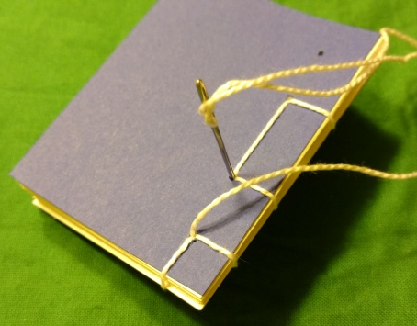
Flip the book again and go into the next middle hole.
Flip the book over and go into the last hole.
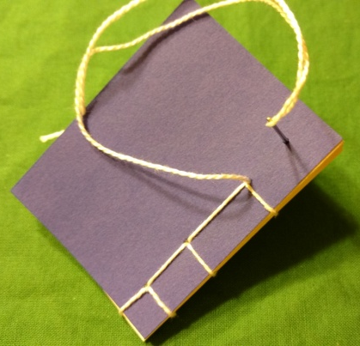
Loop around the spine.
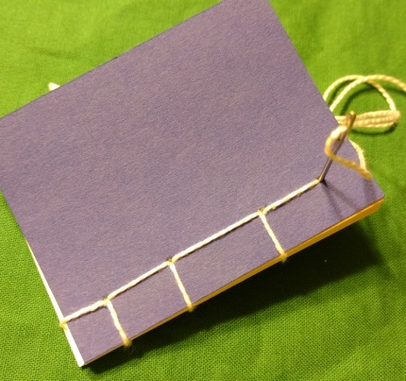
Loop around the bottom (or top) of the book.
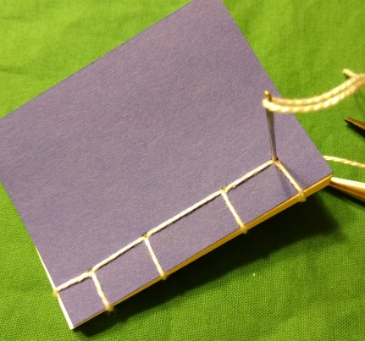
Flip the book over and go into the hole you started with…but only partway through the book. Come out where you started.
Tie the tails together and snip the ends. If you want to, write the title of the book and paste it on the front. I goofed up and put it on the front from a western point of view. It ought to have gone on the other side.
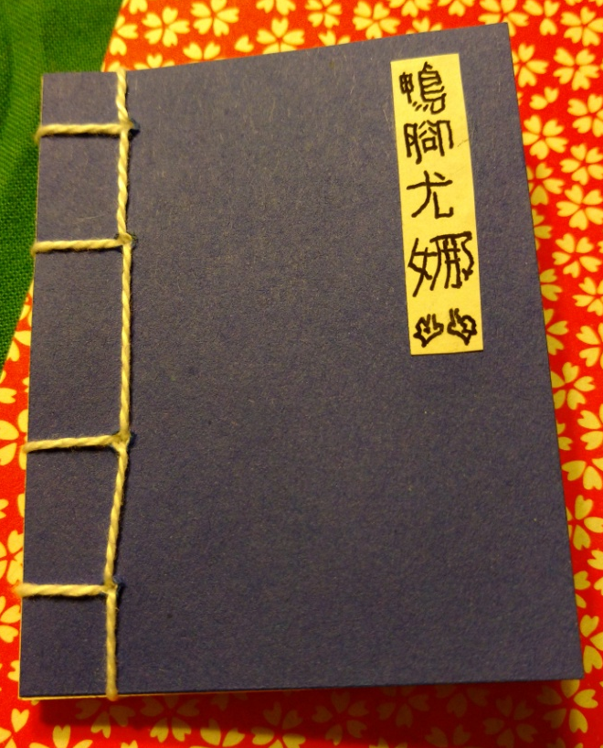
The title is Google Translate’s version of Duck foot Una, or at least as well as I could reproduce it. It is probably completely illegible. And I notice that my holes are not quite as straight as I wanted them to be.
What I Learned:
After completing the book, the quote from Brave Sir Robin [Holy Grail] springs to mind: “Well that’s EASY!” It looks more complex than it is, and anyone who has done any sewing should have no problems with it. The more complex versions ought to be only as hard as advanced embroidery.
I was annoyed at not being able to find more on the history of various stitches, but I did find a page about a stab-bound sandwich. Repeated searches for, say, the history of the tortoise shell stitch, gave me lots of how to do the tortoise shell stitch but not the history, or the history of tortoise shell in art or something unrelated to bookbinding.
I was also annoyed at the difficulty of finding pictures of books in period Asian art. I found a picture of the author of the Tale of Genji, but the lone book on her writing table was facing the wrong way to see the binding; other pictures depicted open books and I couldn’t see the binding at all. I found waaaay too many manga images.
References:
Wikipedia articles on Traditional Chinese Bookbinding (redirect from Japanese Stab Binding search) and Japanese Books
http://homepages.nildram.co.uk/~dawe5/bookbinding_pages/BB_history2.html , a webpage on Japanese Stab binding
http://www.bookbindersmuseum.org/japanese-bookbinding/ which gave further history of Japanese bookbinding
http://www.designsponge.com/2013/03/bookbinding-101-japanese-four-hold-binding.html a good explanation of the basic technique with pictures
Non-Adhesive Binding: Books Without Paste or Glue, volume 1 by Keith A Smith, ISBN 0-9637682-6-3
http://www.tandfonline.com/doi/pdf/10.1080/19455220802630743 Korean bookbinding history--very good
http://virginiabookarts.org/files/2010/05/StabBindingHandout-VABC-Apr2010.pdf a basic description of how to do a few more complex stitches

