Dyeing with Natural Dyes

Una Duckfoot Pam Arnold

651-262-8079

rparnold@bitstream.net

Colors Science Museum volunteers have achieved.
Description:
The concept of dyeing fabric is probably as old as the concept of weaving cloth. Dyeing is a purposeful application of something that will stain, and anyone who has active kids will discover what in their area will produce stains.
My Goals:
Since the Collections Gallery has been morphed into anthropology (specifically ‘We Move and We Stay’ and ‘Race’), my range of what to demonstrate has been curtailed, but since Native Americans used natural dyes to dye porcupine quills for quillwork, we still do natural dyes and other fiber things.
Another goal is to have something in a third category so I could say I entered the A&S Triathalon.
History and Method:
People have always liked having color in their lives. Colors are even trendy when they are first available, whether purple lamé (1970s Papal cope), fluorescent colors (SMM has collections of both Hmong skirts and Guatemalan huipíles and when they are lined up by year you can tell when fluorescents became available), and aniline dyes (all the rage in the late 1800s).
Natural dyes were used to dye cloth whenever people could afford the time and/or money and effort.
Care must be taken when dying wool lest it felt when you don’t want it to. The keys are to heat and cool slowly and stir very gently. I have dyed my wool before spinning it partly so it will be more challenging not to felt the wool, and partly because I just don’t spin that fast.

Mordants
‘Mordant’ comes from the Latin ‘morderae’ meaning ‘to bite’. The mordant helps the dye bite into the fibers and hold on. Some mordants will also change the color produced; iron ‘saddens’ color while tin brightens colors (but also may make fibers more brittle). At the Science Museum I have access to Alum (potassium aluminum sulfate + tartaric acid), Copper (copper sulfate + tartaric acid), iron (ferrous sulfate [AKA copperas] + tartaric acid), and tin (stannous chloride, sometime combined with oxalic acid). At SMM they use material from chemical suppliers, but pickling alum & cream of tartar are available at better grocers, iron tablets can be had at most pharmacies, and copper sulfate can be found at farm supply stores or aquarium supply stores.
The dye and the mordant can be combined in a single dyebath; this is most likely what professional dyers did in the middle ages. I have not done this because I am using the Science Museum’s dyebaths, which are reused as desired, and the next dozen people to use the dyebath before it weakens and we make up a new batch may not want to use the same mordant as me.
Animal fibers take natural dyes more easily than plant fibers. Mordanting wool in alum takes perhaps an hour or two (or more, depending on how slowly the bath is cooled). At SMM I was taught that to mordant cellulose (cotton for example): you simmer it in alum for 1 hour and leave it soak for another 23 hours. Then do the same in a tannic acid dyebath…and then do it again in alum (for a total of 3 days). Ruth Ladwig has not heard of using any other mordants on cotton before the industrial revolution.
“Alum is a vitriolic clay composed of sulfuric acid, aluminum, and potassium.” (p68 DelaMare) Alum was mined. In the mid-15th century, the expanding Turkish Empire gained control of many important alum mines and imposed heavy taxes on its export, to the likely dismay of dyers in Europe.

Dyes
Madder should be grown 3-4 years before harvest. The Lady and the Unicorn tapestries used, among others, madder, woad, and weld dyes.
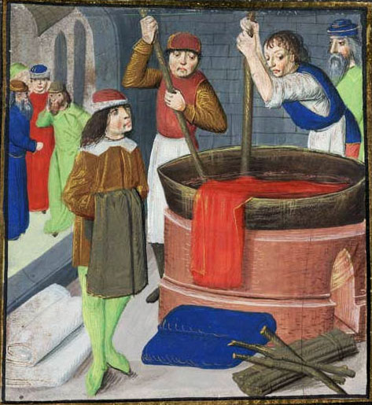
Picture of dyeing red fabric: Dyeing wool cloth, from "Des Proprietez des Choses" by Bartholomaeus Anglicus British Library Royal MS 15.E.iii, folio 269
Goldenrod is a commonly seen plant in Northshield and can be used for dyeing. Using (most likely) zigzag goldenrod (which volunteered to be in my garden) I was able to get a nice yellow with an alum mordant and a chocolate brown with an iron mordant. While North America has many more varieties of goldenrod, Solidago Virgaurea is native to Europe (p60 Cannon). If it is tenacious as its Northshield cousins, it may have been used because it was there.
Brazilwood is actually two different trees. Caesalpinia sappan is native to India and it has been exported to China since 900BCE and to Europe by the early Middle Ages by Muslim traders. The Portugese discovered a similar tree in the new world, Caesalpinia echinata and is likely this species that is used at the Science Museum. It produces a beautiful red with alum, but it is a rather fugitive dye. I dyed some grey spun wool with it, and overdyed that wool with cochineal to make sure some of the red lasts no matter what I do with it.
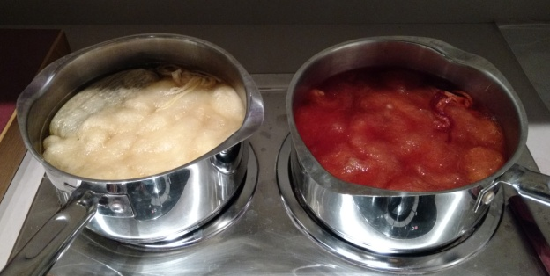
Mordanting in alum & dyeing in brazilwood.
When I went back to dye more with brazilwood, I did not get the gorgeous red I had got the spring before. I thought perhaps I had not mordanted it properly, so I re-mordanted & re-dyed it. No good; at best it is orangey. I now have an idea of how to tell if a dyebath is exhausted.
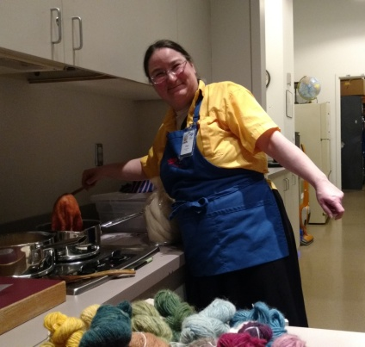
Weld was widely used in medieval Europe. It is especially lightfast, and occasionally some localities banned the use of other yellow dyes (which faded much faster). (p110 Cannon)
When my weld finally arrived, I think I left it in the dyebath overlong in fear of cooling it too quickly and shocking it into felting. I didn’t get the nice clear buttercup yellow.
The Woolery website claims that the leaves of Lily of the Valley will produce green. I may try this later this spring, but I wasn’t thinking about A&S early enough last year. Very few things actually produce green.
Indigotin is the active chemical in dyeing that is produced by both indigo and woad. It is also chemically similar to dibromindigo which is the main component of Tyrian Purple, used by the Phoenicians in 1570BCE. Tyrian Purple is produced by a variety of the murex snail found in the Mediterranean. 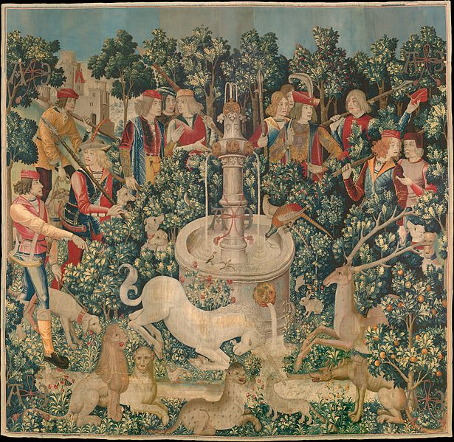
The Unicorn is Found, one of the series of seven tapestries The Hunt of the Unicorn between circa 1495 and circa 1505

Woad is native to the Caucases, and has been cultivated in Europe since at least the iron age, and there is evidence of its cultivation in France during the Neolithic. Indigo is native to India and produces more indigotin than woad. In the late 15th century a sea route to India was discovered and by the mid 16th century laws had been passed in several European countries (including parts of France and Germany) to protect the local woad industry from the foreign indigo.
Indigo is a substantive dye rather than a adjective dye, which means it will color fibers (and fingernails) without a mordant. It is the most complicated dye used at the Science Museum. The dyebath is raised no more than 120°F (over 130°F the indigotin molecule breaks down) and then vermiculite (Thiurea Dioxide) is added to draw off the oxygen in the dyebath. After half an hour, it is supposed to turn a pale yellow-green; I have not been able to manage this. It can be a showstopper dye with the yellowish fluid running off the fibers which then turn blue before your eyes. However, even when the dyebath is blue (too much oxygen) it will still dye. 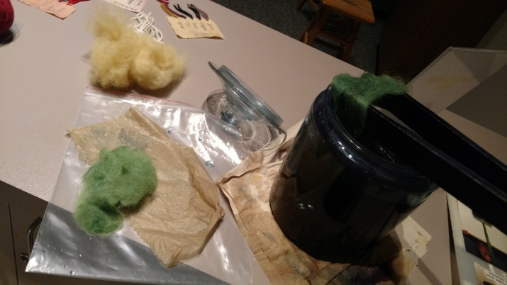
Wool dyed with weld overdyed in woad (or indigo) produced Lincoln Green. Green achieved!
In the middle ages (and before) woad and indigo would have involved a recipie involving [wood] ash, salt, indigo or woad (often fermented), and the urine of pre-pubescent boys.
What I Learned:
Dyeing in the wool may produce more ingrained color, but the extra worry of accidentally felting the wool isn’t worth it. It takes dye as well afterward.
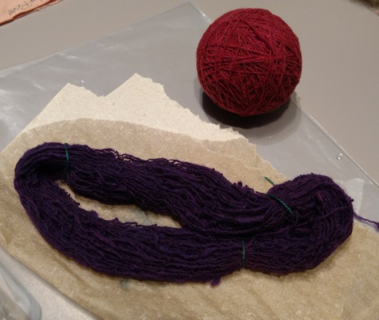
Ball dyed with Brazilwood & overdyed with cochineal, skein of the same overdyed with indigo.
References:
Dye training for volunteers at the Science Museum of MN, put on by Ruth Ladwig.
Colors: The Story of Dyes & Pigments by François DelaMare & Bernard Guineau
Dye Plants & Dyeing by John & Margaret Cannon
Wikipedia articles on dyes and dyeplants

Woolery.com on 18-Nov-2015: Information on Natural Dye Plants and Mordants

