NAALBINDING
Naalbinding is a technique where a single, large, eyed needle, much like a tapestry needle, is drawn though previous loops to create knots that, if cut, will tighten and stop from running. Pre-dating knitting and crochet, naalbinding is one of the oldest methods of creating fabric. Although most extant pieces have been found in the Scandinavian areas, examples have been found in China, Egypt, Italy, Peru and even the United States. The oldest fragments, dated to 8000 B.C., were found in Nehal Hemar, a cave in the Judean desert, Israel.(1) Since naalbinding is mostly worked in the round, common items are hats, mittens, socks, and milk strainers.

When beginning naalbinding, the easiest yarn to work with is 100% wool since naalbinding is done with limited lengths, new pieces can be felted to the old to create one longer piece without tying knots. (It is possible to naalbind with other materials, but other joining techniques are needed.) When learning, it’s best to use light colored yarn because you can see the stitches better. Avoid superwash wools and other wools that have been treated to prevent felting. Starting off, I suggest wool roving. It isn’t plied, very chunky and works up fast. My favorite is Paton’s Roving. I have trouble finding it in stores, but it is available online at Joann’s.com in lots of colors.

Blunt needles have been discovered in many different archeological digs, but only one has ever been found in an unfinished naalbinding project. This needle was found in a Persian shoe, 15 cm long and resembles a long modern darning needle.(2) Shorter versions made of bone, wood, metal and antler were unearthed in various areas around Europe, such as Birka, Sweden and Hedeby, Denmark. For modern naalbinders, good options for needles are found made of blue plastic or metal at sewing stores like (again) JoAnn’s. They come in packages of 3-5, usually for under $10. If you want to get a little fancier and use wood or bone needles, there are a number available on Etsy or google naalbinding needles.
The pictures are presented for a right handed person.
The Oslo Stitch
Start by making a “pretzel”. | 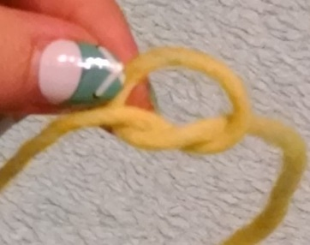
For right hand-the short end will be on the right side of the thumb and the long end attached to the needle should ALWAYS fall between the thumb and index finger.  For left hand-the short end will be on the left side of the thumb and the long end attachced to the needle should ALWAYS fall between the thumb and index finger. | 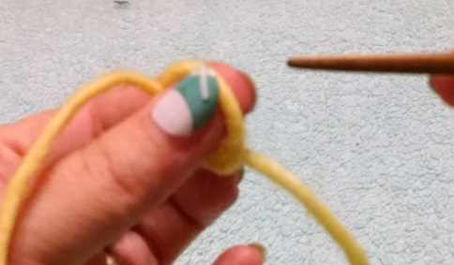
The loop (halo) should rest on the top of your thumb and finger and not be caught between the finger and thumb. | 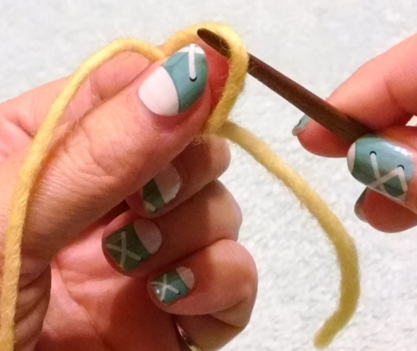
To make the “cuticle” loop, bring your needle in front of the thumb, through the circle made by the thumb/index. Pull until snug.  Notice how I have the small tail held out of the way, this is important because it can get wrapped into your stitches and make a mess. | 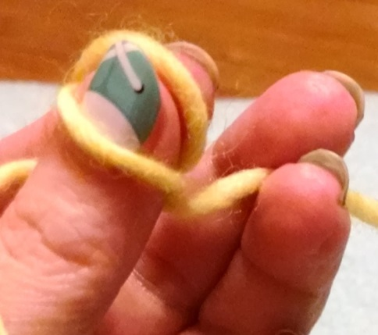
Insert the needle into the “halo” from front to back. | 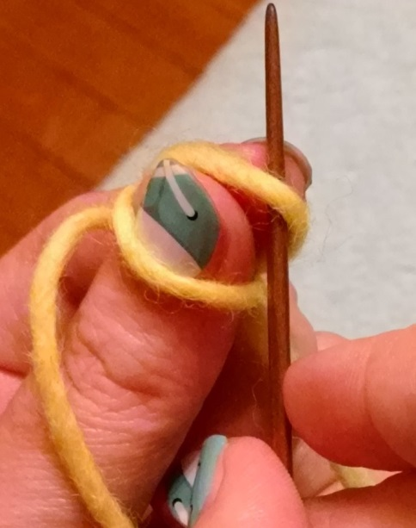
Twist needle to point toward hand, go under the “cuticle loop” and long thread that is attached to the needle.  DO NOT PULL THROUGH YET! | 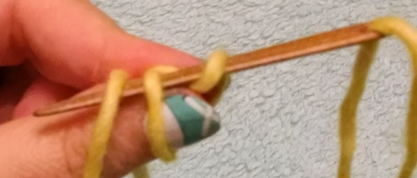
This is where is gets a little tricky.  Lift your index finger and slide the needle back. This will put the “halo” onto the needle and you will be holding nothing. | 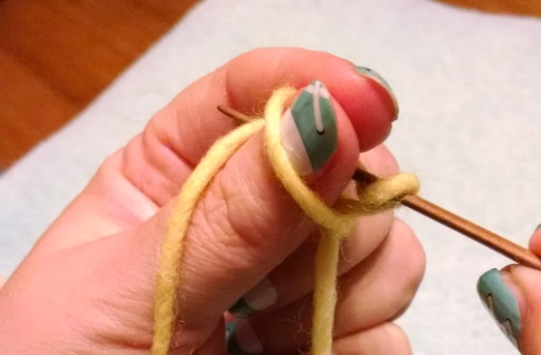
Slide the “cuticle loop” up to be your new “halo”. | 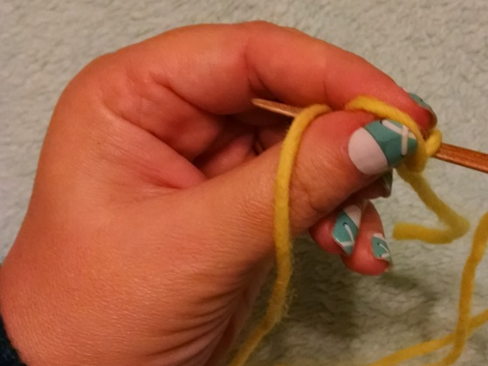
NOW you can pull the needle all the way through.  I suggest you don’t pull too fast, take the time to see where everything is going. | 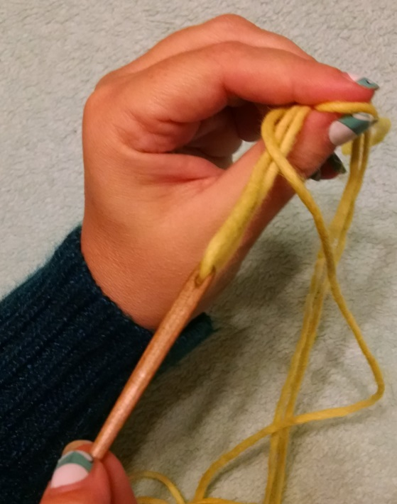
This is what it should end up looking like.  Go back to the “insert needle into halo” step and repeat.  The first few stitches will be ugly, that’s just the way it is. | 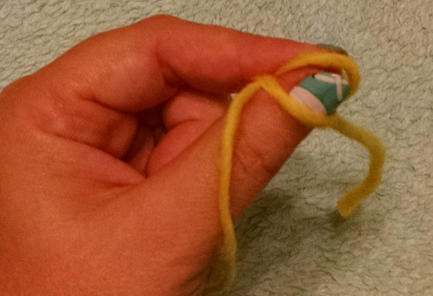

Taking a break – So what do you do if you have to answer the phone/use the bathroom/get a snack? Simply pull the cuticle loop very loose and take your finger out. When you come back, you’ll know which loop to put around your thumb again.
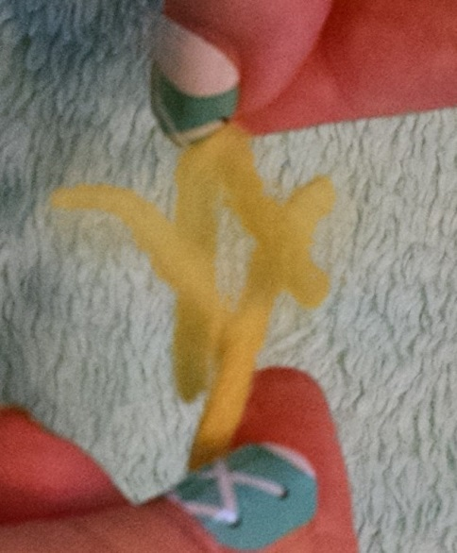
When you run out of yarn – I mentioned that with wool you can add on new lengths by felting. This can be done by fraying out the ends of both the old and the new yarn. I make the ends into Y’s. Slide the y’s together, wet them (either with water or put them in your mouth and chew), then roll between your palms vigorously, to create heat and friction, until it has felted into one piece.
To end - When your project is done, simply pull tight and weave in what is left. Once you’ve gotten the hang of naalbinding, you will want to start making your stitches smaller about 3 stitches before you want to end. This will give a more polished finish.

Have fun and good luck!
THL Taryn MacTavish/mka Kendi Edwards tarynmaeve@gmail.com Nov. 1, 2015

Resources

- Nalbinding, What in the World is That, Ulrike Clausen-Buttner, pg. 32
- Ancient Danish Textiles from Bogs and Burials, Margrethe Hald, pg. 279-280

Videos I’ve found very helpful:
https://www.youtube.com/watch?v=rjSaIriNMZY&index=20&list=UUDRP7lpwfwvmOWckxqhsg9A It is completely in German, but very easy to follow.
https://www.youtube.com/watch?v=McX84c67ny0&list=UUDRP7lpwfwvmOWckxqhsg9A This one is showing the York stitch in English. The only difference between this one and Oslo is going up through the “halo” first before going down into the “cuticle”.

Yarns and needles:
Metal tapestry needles: http://www.joann.com/dmc-tapestry-hand-needles-/prd11069.html#q=tapestry%2Bneedle&start=3
Etsy needles: https://www.etsy.com/search/handmade?q=naalbinding+needle&order=most_relevant&ref=auto2 Or make your own by punching a hole in a popsicle stick and sanding it down to whatever shape is comfortable for you.
Wool roving: http://www.joann.com/patons-classic-wool-roving-yarn/zprd_10138618b.html#q=Paton%2B%2Bwool%2Broving&start=1

