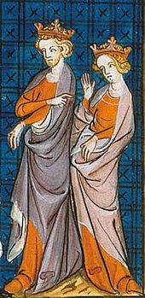
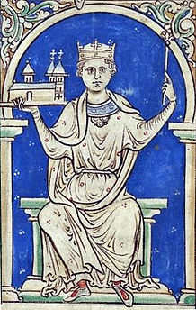
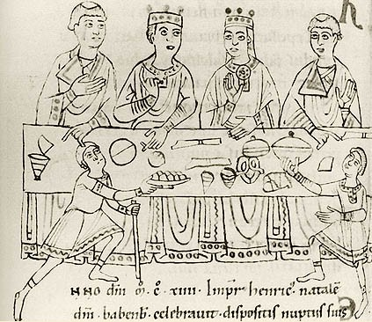
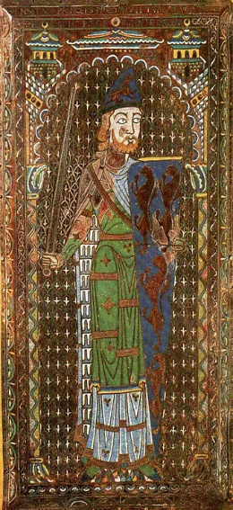
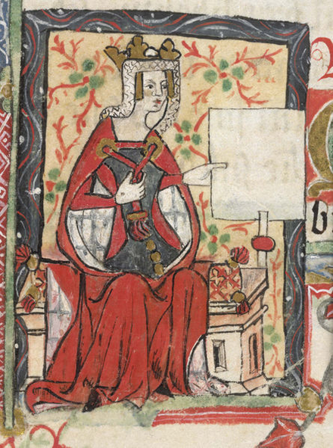
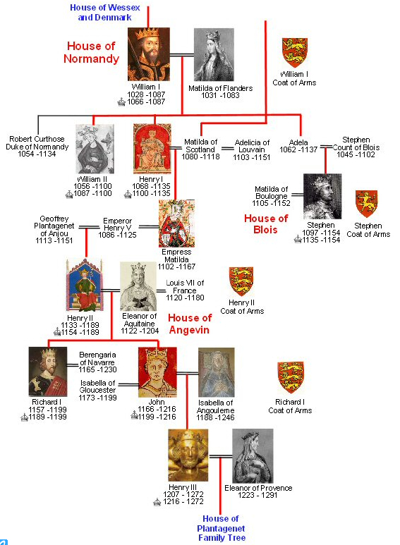
The Throne Is Mine!
Matilda of England, Henry FitzEmpress and what really happened...
Matilda, 1140
by Cobflaith ingen Sitriucca meic Ímair

The throne is mine
My living brothers are all bastards
The throne is mine
The nobles swore to it twice
If Stephen the Oath-breaker thinks he's safe, he's not
For the throne is mine, the throne is mine

At eight years old a queen, I made Germany my home
With twenty thousand silver marks to help Heinrich subdue Rome
The Pope made him Emperor with unwilling hands
In four years, we were wed; in fifteen, Heinrich was dead

My brother, William, five years earlier, King Henry's chosen heir
Had drowned crossing the channel, too much wine the culprit there
I went home a widow; Father's new wife bore no sons
And all the nobles fought to be the first to swear I was the one

CHO:

To strengthen our border to the south of Normandy
I must wed the heir to Anjou, my Royal Father had decreed
A fifteen-year-old peacock was never my choice
I'm a woman who has ruled, yet I seem to have to have no voice

After years of estrangement and Father's maneuvering
The nobles swore again support for my right to succeed the King
I rejoined my husband and bore two healthy sons
Yet Father still refused to give my husband castles he had won

CHO:

I was far away in Anjou when I heard the King was dead
My cousin Stephen seized the treasury, put the crown upon his head
I took the castles denied us, but had to stop to bear a son
By the time I had recovered, Stephen's treachery was done

I got a foothold in my country; my brother Robert joined my quest
After five years of battle, the pretender we did best
The Lady of England was the title given me
As Stephen rotted in his chains, I proclaimed my sovereignty

CHO:

In two years' time, my mother, the great Matilda, was betrayed
She fled to safety with her knights, and Stephen once more King was made
But she never gave up and she fought anew for me
And she raised me up a warrior to defeat our enemy

We claimed Normandy as ours and closed in on Stephen's men
Stephen feared our might, so a treaty we did pen
He remained King until death, as we allowed
Then, after nineteen years of bloodshed, King of England I was crowned

The throne is mine
My mother fought for our birthright
The throne is mine
That is why I shall be known
As Henry FitzEmpress, son of the great Matilda
The throne is mine, the throne is mine
The throne is mine, the throne is mine

©2014 Robin Lea Fritche
cobflaith@gmail.com

Timeline for the Empress Matilda
By Jone Johnson Lewis
http://womenshistory.about.com/od/empressmatilda/a/matilda_timelin.htm

1101 - Henry I became King of England when his brother William Rufus died, quickly seizing control to displace his other older brother, Robert "Curthose."
August 5, 1102 (disputed) - Matilda, or Maude, born to Henry I, Duke of Normandy and King of England, and his wife, Matilda (also called Edith) who was a daughter of King Malcolm III of Scotland.
She was born at the Royal Palace in Sutton Courtenay (Berkshire).
1103 - William, brother of Matilda, born.
April 10, 1110 - betrothed to Holy Roman Emperor, Henry V (1081-1125)
July 25, 1110 - crowned Queen of the Germans at Mainz
January 6 or 7, 1114 - married to Henry V
1117 - Matilda visited Rome where she and her husband were crowned in a ceremony led by Archbishop Bourdin (May 13). This coronation, which was not by the Pope though she possibly encouraged that misunderstanding, was the basis for Matilda's courtesy title of Empress ("imperatrix") which she used in documents all of her life.
1118 - Matilda's mother died
1120 - William, Henry I's sole surviving legitimate male heir, died when the White Ship was wrecked while crossing from France to England. Henry fathered at least 20 illegitimate children, but was eventually left with just one male legitimate heir and, at the death of William, only with Matilda as legitimate heir
1121 - Henry I married a second time, to Adela of Louvain, apparently still hoping to father a male heir
1125 - Henry V died and Matilda, childless, returned to England
January 1127 - Henry I of England named Matilda his heir, and the barons of England accepted Matilda as the heir to the throne
April 1127 - Henry I arranged that Matilda, age 25, marry Geoffrey V, Count of Anjou, age 15
May 22, 1128 - The Empress Matilda married Geoffrey V the Fair, heir to Anjou, Touraine and Maine, at Le Mans Cathedral, Anjou (date is also found as June 8, 1139) - the future Count of Anjou
March 25, 1133 - birth of Henry, eldest son of Matilda and Geoffrey (first of three sons born in four years)
June 1, 1134 - birth of Geoffrey, son of Matilda and her husband. This son was later known as Geoffrey VI of Anjou, Count of Nantes and Anjou.
December 1, 1135 - King Henry I died, probably from eating spoiled eels. Matilda, pregnant and in Anjou, was unable to travel, and Henry I's nephew Stephen of Blois seized the throne. Stephen had himself crowned at Westminster Abbey on December 22, with the support of many of the barons who had sworn their support for Matilda at her father's request
1136 - birth of William, third son of Geoffrey of Anjou and the Empress Matilda. William was later Count of Poitou.
1136 - some nobles supported Matilda's claim and fighting broke out in a few locations
1138 - Robert, Earl of Gloucester, a half-brother of Matilda, joined with Matilda to unseat Stephen from the throne and install Matilda, sparking a full-fledged civil war
1138 - Matilda's maternal uncle, David I of Scotland, invaded England in support of her claim. Stephen's forces defeated David's forces at the Battle of the Standard
1139 - Matilda landed in England
February 2, 1141 - Matilda's forces captured Stephen during the battle of Lincoln and held him captive at Bristol Castle
March 2, 1141 - Matilda welcomed to London by the Bishop of Winchester, Henry of Blois, Stephen's brother, who had recently switched sides to support Matilda
March 3, 1141 - Matilda was ceremonially proclaimed Lady of the English ("domina anglorum" or "Anglorum Domina") at Winchester Cathedral
April 8, 1141 - Matilda proclaimed Lady of the English ("domina anglorum" or "Anglorum Domina" or " Angliae Normanniaeque domina") by a clergy council at Winchester, supported by the Bishop of Winchester, Henry of Blois, brother of Stephen
1141 - Matilda's demands on the City of London so insulted the populace that they threw her out before her formal coronation could happen
1141 - Stephen's brother Henry changed sides again and joined with Stephen
1141 - In Stephen's absence, his wife (and maternal cousin of the Empress Matilda), Matilda of Boulogne, raised forces and led them to attack those of the Empress Matilda
1141 - Matilda escaped dramatically from Stephen's forces, disguised as a corpse on a funeral bier
1141 - Stephen's forces took Robert of Gloucester prisoner, and on November 1, Matilda exchanged Stephen for Robert
1142 - Matilda, at Oxford, was under seige by Stephen's forces, and escaped at night dressed in white to blend in with the snowy landscape. She made her way to safety, with only four companions, in a picturesque incident which has become a favorite image in British history
1144 - Geoffrey of Anjou won possession of Normandy from Stephen
1147 - Death of Robert, Earl of Gloucester, and Matilda's forces ended their active campaign to make her Queen of England
1148 - Matilda retired to Normandy, living near Rouen
1140 - Henry FitzEmpress, eldest son of Matilda and Geoffrey, named duke of Normandy
1151 - Geoffrey of Anjou died, and Henry, who becomes known as Henry Plantagenet, inherited his title as Count of Anjou
1152 - Henry of Anjou, in another dramatic episode, married Eleanor of Aquitaine, a few months after her marriage to Louis VII, King of France, was ended.
1152? - Eustace, son of Stephen by Matilda of Boulogne, and Stephen's heir, died
1153 - Treaty of Winchester (or the Treaty Wallingford) named Matilda's son Henry heir to Stephen, bypassing Stephen's younger son, William, and agreeing that Stephen should remain king for the duration of his own lifetime and that his son William would keep his father's lands in France
1154 - Stephen died unexpectedly of a heart attack (October 25), and Henry FitzEmpress became king of England, Henry II, the first Plantagenet king
September 10, 1167 - Matilda died and was buried in Rouen at Fontevrault Abbey

