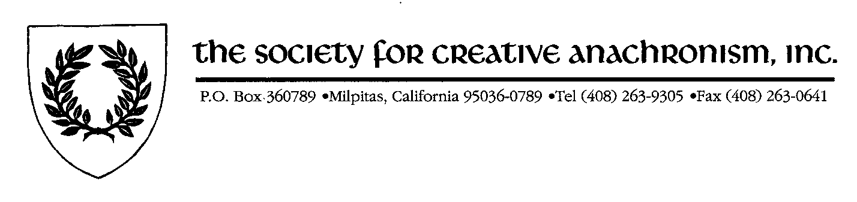

Proposal for
Remaining Bone Donation Allocation

Back in the year 2000, Christopher and Victoria Bone donated $40,000 to the SCA for the purchasing and distribution of dance manuals. Due to a variety of issues, there is still approximately $36,000 left of the donation. Since the money is restricted, I contacted The Bones to discuss the possible uses for the remaining funds. Mr. Bone still wishes to have the money go towards dance education within the SCA.

Basically, we need to make sure that the SCA spends the donation in a way that is following the wishes of the Donor. However, we also need to make sure that what is proposed does not become an administrative nightmare. I really believe this to be a good solution with the right controls in place.

Revised Fund Mission

Promote knowledge of historical dance practice within the SCA and improve relationships with the community of academic dance researchers by:
- Purchasing and distributing (at the baronial level or other group level as determined to be practicable and effective by the Committee) translations and editions of original dance sources edited by academics, dance scholars and musicologists.
- Arranging for master classes and similar teaching opportunities by prominent professional dance historians.
- Promoting other activities unanimously agreed to by the Committee that are
  - consistent with the promotion of historical dance practice within the SCA and
  - provide markets for the work of academic dance researchers.
Fund expenditures shall be solely used to purchase materials, classes and other items from the academic dance community and to pay for the reasonable costs of administration; in no event shall the fund directly support publications by members of the Committee.

Dance Fund Oversight Committee

The expenditures of the Fund shall be overseen by a committee of up to 5 members. Membership on the Committee shall be limited to Companions of the Order of the Laurel who are regarded as eminent dancers and instructors of dance within the SCA. Members shall serve a three year term and may be reelected without limit. New members will be elected by the Committee in keeping with the membership criteria and subject to veto by the Board of Directors. All members serve at the pleasure of the Board of Directors.

A quorum shall consist of 3 or more members meeting either in person or by electronic communication (conference call or similar mechanism where each can hear the others).

Initial membership of the Committee is suggested as the following [all have been contacted and indicated preliminary agreement to serve. Note, while the SCA may, of course, wish to vet the composition of the Committee, they represent most of the leading dancers and instructors within the SCA at this point.]

Chair – Greg Lindahl (Master Gregory Blount of Isenfir, West)
Meredith Courtney (Countess Mara Kolarovna, East)
Del Elson (Master Delbert von Strassburg, Lochac)
Vivian Stephens (Mistress Rosina del Bosco Chiaro, Ealdormere)
Peter Durham (Master Trahaearn ap Ieuan, An Tir)

Committee functions:
- Determine programs to be supported by the Fund
- Arrange with vendors (publishers, dance historians, venues, etc.) for purchase of materials and services.
- Manage the logistics of delivery of materials and services to SCA members and groups.

Financial Oversight

  - Financial oversight will be by a person not on the committee. This person will either be the Corporate Treasurer of the Society for Creative Anachronism, Inc. or a deputy selected by the Corporate Treasurer.
  - The Dance Committee will fill out a short form with the following information:
- Description of the material or service to be purchased.
- Statement that the disbursement meets the donation requirement.
- Statement that the committee approved the disbursement.
- How and when the materials/services will be distributed or used.
- Copy of the Purchase Order or Invoice.

  - The committee will forward the form to the Treasurer’s office for approval and submit it to the Corporate Office for payment.
  - Custody of the funds stays with the Corporate Office.

